https://www.worldoil.com/
GPB Field Manager
El Sistema de gestión de data “GPB Field Office” es una plataforma que brinda acceso rápido a la información importante para los gerentes, ingenieros y otros involucrados en el proceso.
“GPB Field Office” busca ser un primer paso en la automatización inteligente de gestión de data, análisis, diagnóstico y optimización en base a las nuevas tendencias de “Big Data managment” para campos Petrolíferos.
Desarrollado pensando en los diversos tipos de usuario (Gerentes, Ingenieros, Técnicos), “GPB Field Office” es una plataforma en constante evolución creada en base a la experiencia de personal de alto nivel basados en sistemas de gestión de base de datos integrados y de acceso multiusuario.
La plataforma tendrá como funciones principales:
- Una interfaz fácil de usar que proporciona una experiencia gráfica para el usuario, sin requerir una capacitación significativa.
- Escalabilidad que permite administrar un número creciente de pozos.
- Una base de datos Mysql que permite integrar sin problemas con los sistemas existentes sin la necesidad de herramientas especiales para acceder a los datos.
- Análisis de pozos basados en vistas de variables operaciones de los pozos, utilizando vistas tipos desarrolladas en base a metodologías de análisis globalmente utilizadas.
- Gestión de reportes de los pozos basados en etiquetas, estados, etapas de forma rápida.

Variables

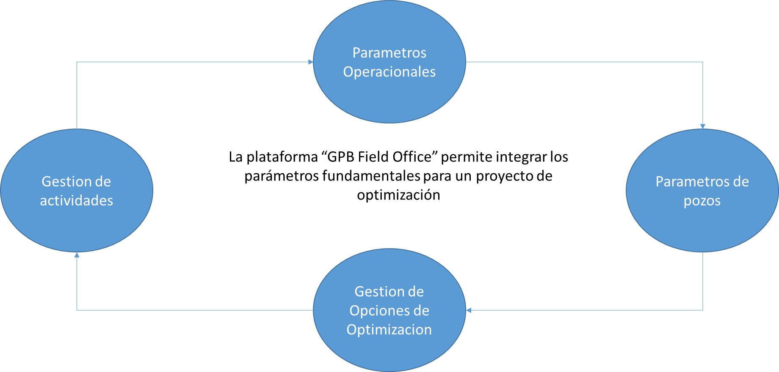

PROBLEMA

Soluciones del sistema de monitoreo, control, análisis y gestión de tareas
- Adquisición

Bombeo Mecánico
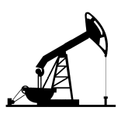

- Cartas
- P y T Operación
- SPM
- Consumo Eléctrico

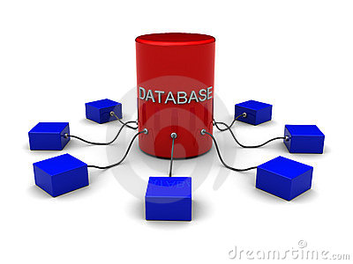
Bases de Datos Externas
- Producción
- Eventos
- Información adicional de otros departamentos

- Almacenamiento y filtrado
- Bases de datos MySQL (Server) que permite a varios usuarios compartir y analizar información de forma simultanea
- Estudio de Tendencias, en periodos variables y vistas personalizables por usuario
- Grupos estáticos o dinámicos según condiciones operacionales.
- Módulos de diagnóstico para BM
- Reportes dinámicos según condiciones operacionales

Almacenaje de la información en servidores, según estructura XSPOC

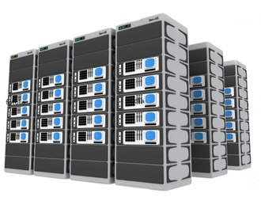

Acceso a la información por medio de exploradores Web , bajo cuenta individual por usuario y credenciales por nivel
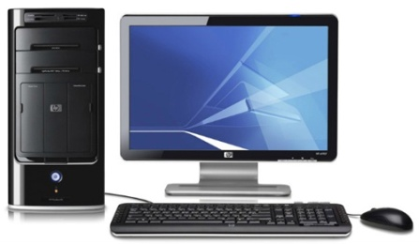

4 VISTAS
- PROYECTOS
Resumen Estadístico del Status Actual de los Proyectos en ejecución
Incluye: Actividades pendientes / Actividades Programadas / Status Actual Pozos / Link otras estadísticas: Bombas Eficientes / Bombas Trabajando con fallas mecánicas / Diferida / Mapa de corte de agua / Mapa de oportunidades (cambio de tiro, cambio de bomba, aumento de RPM, aumento de SPM, rediseño)
Cada monitoreo es analizado por optimización para la definición de oportunidades
Cantidad de estudios realizados (cartas dinagráficas, niveles de fluidos, pruebas de presión, pruebas de válvulas, asentar y espaciar –reespaceo-, aumento de tiro, cambio de correa, balanceo, cambios de empaque y otras actividades generales (revisión de la unidad de superficie)
Cantidad de Problemas:
Pozos sin motor / frenos malos / pozos que requieren empaque / unidad de superfice)
- POZOS
Resumen de Actividades Ejecutadas en Pozo
Parametros de pozos
El modulo parámetros de pozos sirve de base para la gestión de aquellas variables propias del pozo que no son manejables por las cuadrillas de superficie de forma directa, en general variarían según el método de levantamiento, en la fase actual de desarrollo este modulo gestionara las propiedas inerentes a la zona de drenaje del yacimiento al cual el mismo pertenece, entre las principales variables que almacena y maneja este modulo se encuentran:
- Presion estatica del yacimiento para la zona de drenaje
- Equipos de fondos (diagramas mecanicos)
- Equipos de superficie
- Velocidad requerida
- Categoria del pozo
- Permeabilidad
- Porosidad asociada
- Propiedades petrofisicas ineherentes a la zona de drenaje
- Caudales de produccion (tasa liquida, porcentaje de agua y sedimiento, tasa de gas, entre otras)
- Historia de los problemas operativos del pozo
- Toma de carta Dinagrafica con HT.
- Toma de carta Dinagrafica con PRT.
- Toma de carta con Leuther
- Reespaceo de Pozos Bombeo Mecánico.
- Reemplazo de Barra pulida, stuffing Box y adición de sobres.
- Toma de nivel de Fluido
- Ajustes de velocidad

- ACTIVIDADES
El módulo de Gestión de actividades permitirá llevar un control sobre las rutas de monitoreo, así como los resultados de los monitoreos diarios, este modulo le permite a los usuarios la gestión de las siguientes variables:
- Personal que realiza la actividad.
- Variables operacionales recopiladas durante el monitoreo de los pozos (Nivel de fluido, Carta dinagraficas, presiones, entre otras segun aplique a cada caso).
El modulo de Parámetros operacionales manejara todas las variables recopiladas por las cuadrillas de superficie, los parámetros que se registran variaran según el método de levantamiento artificial instalado en el pozo, este modulo permite por medio de vistas graficas poder realiazar un vistaso rapido del estado del pozo hasta la ultima visita por las cuadrillas de monitoreo, algunas de las variables a manejar serian las siguientes aun cuando la plataforma es versatile en la gestion de variables adicionales:

- Modelo del Balancin en superficie  - Nivel de fluido  - PIP | - Carta dinagrafica  - SPM  - Cargas maximas  - Cargas Minimas

- OT (orden de tradabajo que autoriza la actividad), asi como el historico de usuarios que solicitan dicha actividad.
- Procedimiento realizado durante el monitoreo.
- Reporte de recorrido en digital.

- VISTA TENDENCIA
Modulo básico de monitoreo y análisis de pozos
Permite al Ingeniero de Optimización diagnosticar de forma rápida la condición actual del pozo.

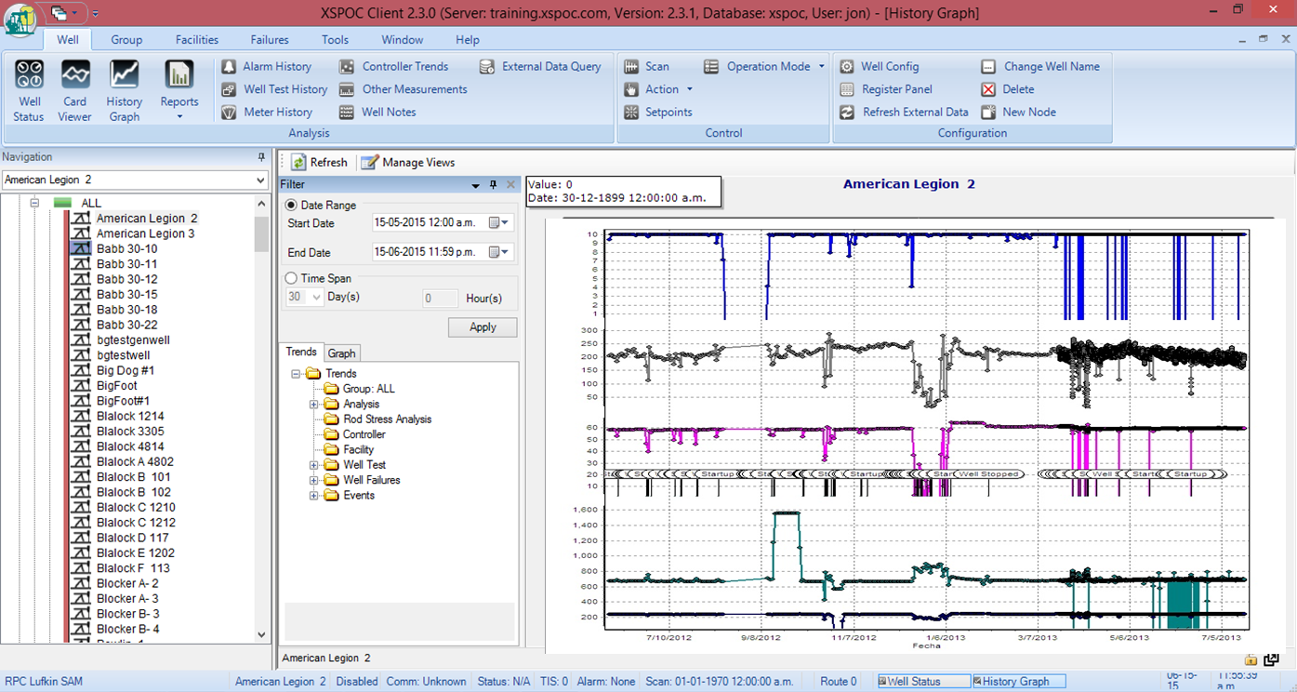

Gestion de Opciones de Optimizacion
El modulo de Opciones de Optimización, permite gestionar de forma rápida el mapa de posibilidades de optimización y en analisis de las posibilidades que salen del análisis de los monitoreos realizados por las cuadrillas de campo, este modulo permite gestionar las actividades que en mesa de trabajo conjunta se descubran del trabajo conjunto de los optimizadores de Petrozamora y los asesores GPB.
Este modulo permitirá también el fácil seguimiento de las actividades requeridas para lograr incrementar la producción o la mas idónea forma de operar el método de levantamiento artificial, este modulo gestiona el grupo de etiquetas dinámicas que permitan la generación de reportes.

RECOMENDACIONES
Optimización
- Evaluación de problemas operativos de forma detallada
- Predecir comportamientos

GPB-NEFT GAS SERVICES Empresa de Asesoría de Optimización de Pozos.
Acceso limitado a la información de pozos de la base de datos corporativo: diagramas mecánicos, histórico de trabajos de subsuelo, datos de producción, estatus actual de los pozos.
Base de datos corporativa cuenta con distintos visualizadores, consume tiempo realizar múltiples consultas:
Diagramas Mecánicas (Sistema Integrado Optimización de Producción / SIOP)
Histórico de Trabajos (SISUB)
Data Producción (Centinela)
Para la optimización de pozos se utiliza la metodología de monitoreo de Echometer (Total Assit Monitor / TAM)

Diagrama de Metodología de Optimización



Eficiente el workflow de la Optimización:
The new application contributes to the provision of information within a much shorter time. This system is called 'WELLVIEWER' in view of its several benefits to the users of production databases, thereby, accelerating timely decision-making through many studies and analysis of different information available in many databases.
Be the main gateway for all production and field information to access all the user's needs of integrated data, relate to each other.

DATA INPUT
CAMPOS: (Información General)
Bachaquero Tierra / Lagunillas Tierra
Bombeo Mecánico

FRECUENCIA 2 o 3 veces MES POR POZO
TOTAL 1425 POZOS ACTIVOS
DATA VARIABLES OPERACIONALES
Cartas
CHP / THP /
Bombeo Mecánico
Carga máxima
Carga mínima
Sumergencia bomba
Presión entrada de bomba
Pwf
Velocidad (SPM/RPM)
CONDICIÓN FÍSICA
TIPO DE UNIDAD
Tiros Operación
Estado fosa
Estado frenos
Validar aporte en superficie

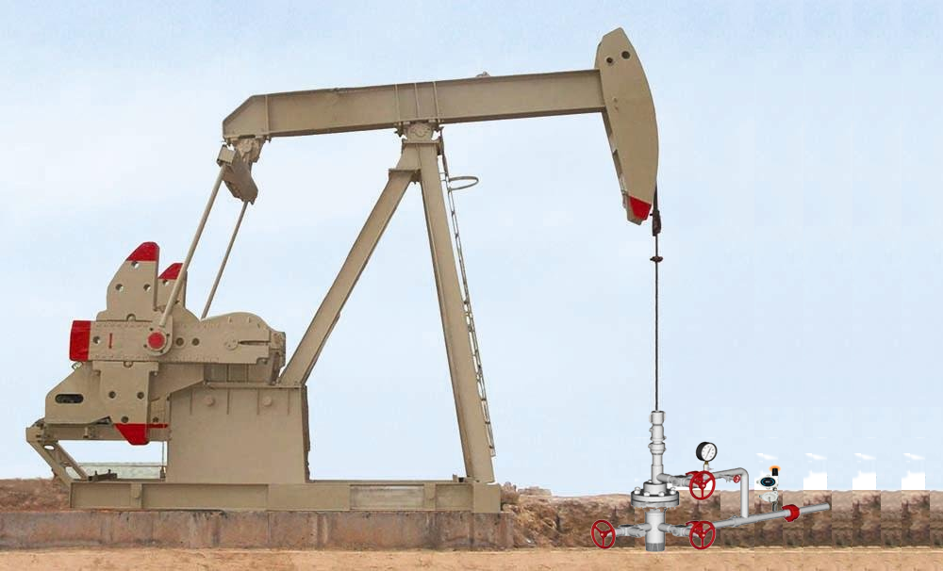

Objetivos:
Gain efficiency

Features:
Easy Navigation
Visualization
Integration (Data Producción / Diagramas Mecánicos / Trabajos a pozos sin Taladro de Servicio (TDS) / Análisis y Recomendaciones)
ESTO ES IMPORTANTE!!!
Data needs to be checked, corrected, formatted and integrated before it is useable for your needs. And even when it’s finally available, users may not trust it.

FLUJO DE TRABAJO

FASES Y METODOLOGÍA DE TRABAJO
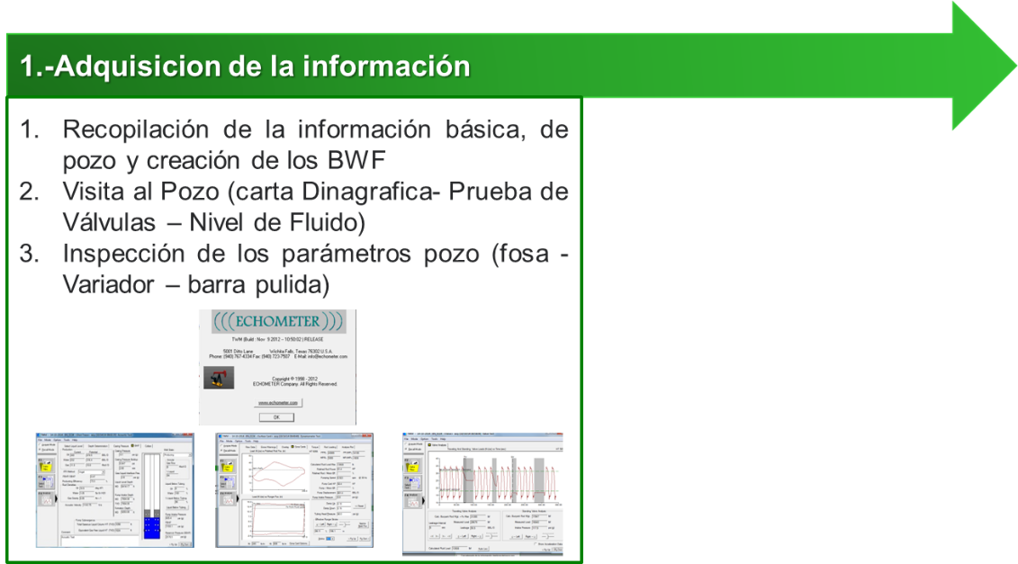

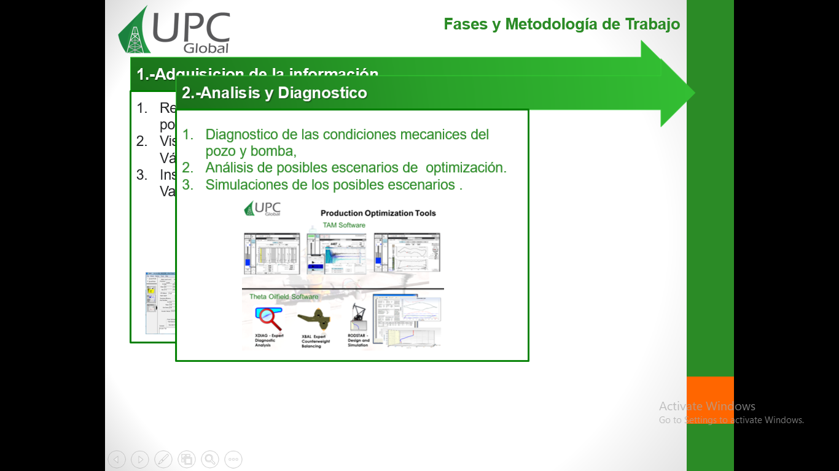

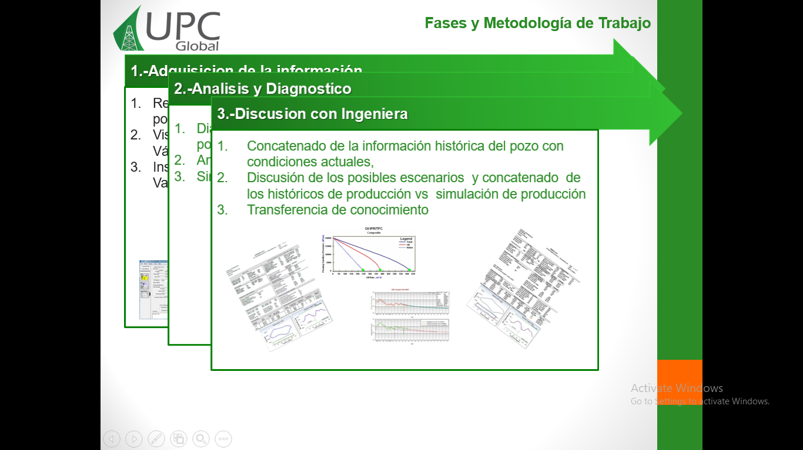
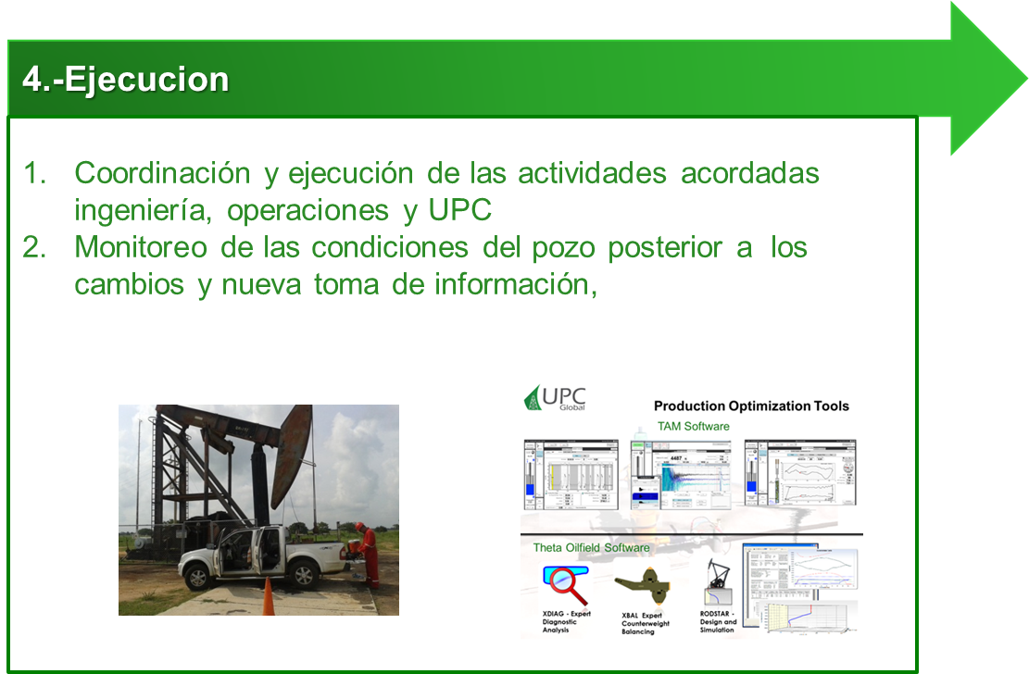
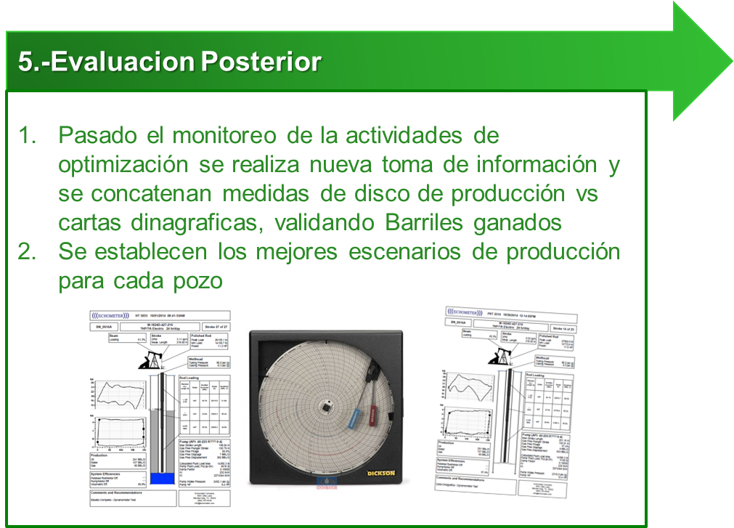

Papers 187840-MS

Several facets and uncretainties are present in petroleum oilfield operations, due to which decision making is a crucial process that ensures operational viability. For the purpose of decreasing risk and providing better insight, uncertainties must be reduced through a well-organized historical database. This is critical especially in the development of new fields.
An understanding of the cause-effect relationship between attributes and outcome of field operations can be gained through statistics. Through the use of statistical methods there is an opportunity to turn large amounts of data into knowledge for efficient decision making. Unfortunately, the lack of a well organized historical database limits the use of these data for improved results.
Data driven models are developed using a statistical model approach based on collection of relevant historical data. However, using historical data only is not sufficient for decision making due to the lack of systematically organized data with potential to be turned into knowledge to improve the result and decision. A multi variable regression is carried out to show the significance of each attribute in the model, which is obtained in a dynamic manner to select the optimum yield results. The result and analysis is then used for future decisions. Data driven technologies have been proven in the oil and gas industry to solve various.
problems in reservoir management. Reservoir management uses the geological, geophysics, petrophysics and petroleum engineering data to predict and manage the oil and gas recovery from a reservoir. The purpose of reservoir management is to control oil and gas operations for maximum possible recovery from a reservoir based on the available information. Reservoir modelling and simulation, waterflood projects, field production forecast using decline curve analysis are some of examples that use data driven models in the oil industry.
Surveillance activity and data acquisition programs give a significant amount of input data for field optimization. Conventional reservoir surveillance is generally composed of seismic data, welltest data, production data, downhole pressure measurements, production logging and fluid sampling. In recent years, new types data sources have become available, such as Distributed Temperature Sensing (DTS), Distributed Acoustic Sensing (DAS), geomechanical data, surface and downhole tilt and displacement, 4D seismic, and Life of Field Seismic (LoFS). A large amount of data is generated from the subsurface, but with constant improvements in surveillance technology data generated from the surface is on the rise as well. Such combinations of different data types enable us to obtain different characteristics of reservoir properties, provide insights of the dynamic reservoir conditions and reservoir response to field operations (Temizel et al, 2016).

Improved Oil Recovery Waterflooding is an example of a technique that uses data driven modelling to improve the recovery of an oil field. The decisions in waterflood application, which relies on project economics, is a crucial factor that attributes to the success of the project. Any oil reservoir should meet the minimum technical and economical criteria to be a candidate for a waterflooding project by improving the oil recovery. During oil production, as hydrocarbons are drawn from the reservoir through the well, reservoir pressure will drop.
SPE-187840-MS 3
Thus, water or any other commercially viable physical or chemical compatible substances are pumped into the reservoir to compensate for this pressure drop. A reservoir simulation tool is used to plot/map reservoir pressure, saturation, and production profiles to visualize the impact of waterflood applications or the injected chemical substances. Outcomes of this reservoir study will be used to evaluate the impact of waterflood/chemical injection support in the reservoir. Also, it will suggest infill wells' drilling strategies, thus, optimizing recovery from the field (Temizel et al., 2016).
Data Driven Modelling Lately, the oil and gas industry has had the need for new technologies and processes to seize and transform data into strategic business intelligence for enhancing exploration and production, improving refining and manufacturing efficiency and optimizing global operations while ensuring safety and environmental protection. With the advent of machine learning, data mining, optimization and cloud computing, it is now possible to manage large amounts of data as never before (Dursun et al, 2014). The objective of data driven methods is to provide the strategy required to utilize data collection and selection to optimize business outcomes and decision making while helping to minimize risk. The
4 SPE-187840-MS
development of data driven methods involves combining a variety of cutting-edge machine learning and data-mining techniques as well as data management strategies to provide fit–for-purpose descriptive, research, predictive, and prescriptive models. Hence, the development team should have a deep understading of both underlying data science and the business model, as well as software engineering principles.
Data Mining & Data Acquisition Technology advancement in computing power in the last few decades has allowed for a paradigm shift from theoretical to computational problem solving. As a result, historical data is being used more efficiently to develop, verify and validate physical theories. Computational paradigm, as with the case of previous techniques, involves modeling and simulation of complex proccesses using available data to minimize the standard deviation error between estimated output results and measured data relevant to these processes (Maysami et al, 2013) Data mining becomes valuable when the conventional reservoir monitoring methods fail to decide field development strategy due to high amounts of uncertainties. Data mining can be defined as extracting hidden patterns from data, especially for cases with more available data. Preparing data becomes time consuming, and more importantly, when there is the need to deal with abnormal patterns of data (Obulesu et al, 2014; Termizel et al, 2016) In the oil and gas industry, data acquisition is extremely costly due to presence of uncertainties. Brown fields pose a challenge due to the lack of any type of data other than production rates. Thus, it can be said, with a good degree of confidence, that a limiting factor in most conventional reservoir simulation techniques is the presence of insufficient data. Data Driven Techniques Reservoir engineering has been integrated with Artificial Intelligence and Data Mining (AI&DM) as the data driven technique in our analysis. Discussed below are a list of processes that were implemented in the study of, 1. Hilighted field dataset review and preparation ◦ Well Logs (available) and Reservoir Characteristics (petrophysical properties) ◦ Production history ◦ Completion details ◦ Workovers and stimulation treatments 2. Delineation and Volumetric Calculations (on a per-well basis) 3. Fuzzy Pattern Analysis ◦ Well Quality Analysis ◦ Fuzzy Trend Analysis ◦ Key Performance Indicators Analysis (KPI) 4. Field-Wide Fuzzy Pattern Recognition ◦ Fixed interval well performance ◦ Remaining reserves estimation (time dependent) ◦ Recovery factor estimation 5. Top-Down Model Development:
SPE-187840-MS 5
◦ Production forecast of proposed wells ◦ Economic analysis On the other hand, there are multiple methodologies involved in the generation of these data driven models, which mainly include – data gathering, data selection, identification of key attributes, history matching and forecasting. Data gathering can vary form simple frequent gathering of data, to storage of data, reporting, documentation and integration. It includes the use of smart wells, such as ICVs, and regular rate recording. Acquisition of data inludes data such as well trajectories, well interventions, production/injection data, coordinated maps, well logs & petrophysical models and geological reservoir models. Storage of this data includes various methods – SQL server integration, volume analysis, Integrated Asset Management (IAM), pumping & drilling databases (Termizel et al, 2016). Machine Learning is the field of study that gives computers the ability to learn without being explicitly programmed. It has been widely employed in a range of computing tasks when it's not feasible to define the rules by hand. There are some techniques of Machine Learning methods based on data driven models, such as Artificial Neural Network (ANN), Capasistance Resistance Models (CRM). Another data driven method is Intelligent Production Data Analaysis (IPDA), that combines conventional production data analyisis methods with new generation intelligent methods (Neural Network, Genetic Algorithms and Fuzzy Logic). Prior to lease acquisitions, for independent asset valuation requirements, IPDA is providng to be a valuable tool. The technique has been applied in several fields around the United States. (Mata et al, 2007). Several data-driven models have been used to optimize field operations and waterflooding projects. Datadriven methodologies used in the oil industry includes – artificial intelligence like neural networks and fuzzy logic and the ones based on driven-model solutions like capacitance-resistance models. In all these methodologies, special care must be considered during data acquisition of variables such as well trajectories, well intervention, production/injection data, coordinated maps, well logs and petrophysical properties and geological information. Data processing and cleaning should be carried out in to get the most accurate results (Temizel et al., 2017). The application of each data-driven model has its own advantages and drawbabacks, these features will be summarized in the following section.

On the other hand, there are multiple methodologies involved in the generation of these data driven models, which mainly include – data gathering, data selection, identification of key attributes, history matching and forecasting. Data gathering can vary form simple frequent gathering of data, to storage of data, reporting, documentation and integration. It includes the use of smart wells, such as ICVs, and regular rate recording. Acquisition of data inludes data such as well trajectories, well interventions, production/injection data, coordinated maps, well logs & petrophysical models and geological reservoir models. Storage of this data includes various methods – SQL server integration, volume analysis, Integrated Asset Management (IAM), pumping & drilling databases (Termizel et al, 2016). Machine Learning is the field of study that gives computers the ability to learn without being explicitly programmed. It has been widely employed in a range of computing tasks when it's not feasible to define the rules by hand. There are some techniques of Machine Learning methods based on data driven models, such as Artificial Neural Network (ANN), Capasistance Resistance Models (CRM). Another data driven method is Intelligent Production Data Analaysis (IPDA), that combines conventional production data analyisis methods with new generation intelligent methods (Neural Network, Genetic Algorithms and Fuzzy Logic). Prior to lease acquisitions, for independent asset valuation requirements, IPDA is providng to be a valuable tool. The technique has been applied in several fields around the United States. (Mata et al, 2007). Several data-driven models have been used to optimize field operations and waterflooding projects. Datadriven methodologies used in the oil industry includes – artificial intelligence like neural networks and fuzzy logic and the ones based on driven-model solutions like capacitance-resistance models. In all these methodologies, special care must be considered during data acquisition of variables such as well trajectories, well intervention, production/injection data, coordinated maps, well logs and petrophysical properties and geological information. Data processing and cleaning should be carried out in to get the most accurate results (Temizel et al., 2017). The application of each data-driven model has its own advantages and drawbabacks, these features will be summarized in the following section.

SPE-190117-MS

The use of data-driven cognitive solutions represents a major advancement in the management of oil and gas operations. Tools that integrate concepts from disciplines such as informatics, machine learning and predictive analytics can offer powerful solutions to allow improvements in the safety, efficiency and integrity of oil and gas operations. We discuss data systems that enhance traditional, human-based monitoring systems, with the aim of approaching risk-free operations. Ethical decision-making is critical in the management of oil and gas operations. Digital data solutions effectively compensate for the limitations of human-based decision processes when confronted with data overload and multi-dimensional data systems. Increased adoption of data gathering, automation, data analytics and advanced computer-aided process control has already made its mark in the industry. Examples have emerged as for how in areas such as artificial lift, pipeline transportation and offshore operations, these data analytics techniques have helped in failure detection and prediction and smart management of such operations. The incorporation of data-intensive decision-making and smart risk management solutions have resulted in a step change in the improvement of the ethical foundation and the base underlying the industry. Moreover, these digital tools and machine-based cognitive processes for risk-avoidance solutions can help to build and restore the public's faith and trust in the industry. We also discuss how relying on digital solutions alone can have its limitations when it comes to professional ethics and responsibilities.
In some operations such as drilling and production, oil and gas professionals often need to make rapid decisions. Science can assist in improving opinion-based decision making and standardized solution systems. However, science needs data, and, to move in the direction of science-based decision making, we need data from multiple sensors plus the historical and performance data. Furthermore, we need ways to validate the data and to be able to use smart analytics to examine massive amounts of data for obtaining timely alerts about im456pending risks, perform consequence analyses, stop system failures and prevent catastrophic accidents from happening

Por tanto, los datos son el medio o la base para llegar a conclusiones y transformar estos datos en información relevante, para que las empresas puedan abarcar mejoras y soluciones que les ayuden a conseguir sus objetivos.

Diferencias entre Data Mining y Big Data
El Big Data es una tecnología que tiene la capacidad de capturar, gestionar y procesar de forma veraz todo tipo de datos, utilizando herramientas o softwares que identifican patrones comunes. Estos patrones podrían ser características específicas de los consumidores, generación de parámetros, métricas, entre muchos otros. Y, tienen la capacidad de cambiar la manera de hacer negocios, ya que permiten aumentar la rentabilidad y productividad de las compañías.
A diferencia del Big Data, tal y como se ha comentado anteriormente, cuando hablamos de Data Mining nos referimos al análisis de los grandes datos o Big Data para buscar y obtener una información concreta, y así, poder ofrecer resultados que sirvan como solución para optimizar las actividades de una empresa.
En resumen, los Grandes Datos o Big Data podrían ser definidos como el “activo” y la Minería de Datos como el “manejo”.
Qué papel pueden tener los grandes datos en el sector petrolero? Los retos de administración de datos que enfrenta la industria de petróleo y gas son inmensos comparados con otras industrias. Las compañías deben enfrentarse al crecimiento de los grandes datos en:
- Amplitud: datos de exploración geofísica, datos de producción en tiempo real, datos de operación de refinería, datos financieros, datos de salud y seguridad, etc.
- Volumen: peta bytes de datos de reconocimiento y terabytes de datos en tiempo real.
- Complejidad: análisis de multi-atributes, transformaciones de Fourier, etc.
- Actualización: envío en tiempo real de datos de flujo de perforación, decisiones sobre seguridad de equipos, control de accesos, etc.
Durante la última década, la industria también se ha estado enfocando en tecnologías de sistemas de información geográficos como la columna vertebral de construir y mantener eficientes los oleoductos.

